Contributor: Camila Maroja

**Volpi, Alfredo**

Born: 1896—Lucca, Italy; Died: 1988—São Paulo, Brazil

One of Brazil’s greatest colorists, Alfredo Volpi immigrated with his parents to Brazil in 1897 and was trained as a painter-decorator by the age of fifteen. This training instilled in him a passion for artistic processes evidenced in the painter’s lifelong habit of stretching his own canvas and preparing tempera paint, a technique he embraced after discovering Giotto in an influential visit to Italy in 1950. His initial production is mostly figurative. Noteworthy from this early period are his 1939-1941 marine landscapes made in Itanhaém, after his encounter with the painter Ernesto De Fiori. From the 1950s onwards his artworks became more abstract. He painted the characteristic colonial façades and decorative little flagspennants (literally *bandeirinhas or* “little flags”),which poetically evoke popular taste and local tradition. Although his oeuvre cannot be easily inserted into artistic movements, Volpi participated in the unofficial ***Santa Helena Group***, (***Grupo Santa Helena*** 1930s) with painters like Mário Zanini and Francisco Rebolo. Additionally, Brazilian **Concrete artists** identified him as their precursor. Indeed, despite never embracing the theoretical program of the group, Volpi exhibited in the famous ***National Concrete Art Exhibitions***(*Exposições Nacionais de Arte Concreta*) in 1956 and 1957. Other important shows include the ***May Salon***(*Salão de Maio,* 1939) and the ***II São Paulo Biennale***(*II Bienal de São Paulo*,1953), which bestowed on him the national prize for painting together with **Emiliano Di Cavalcanti**.

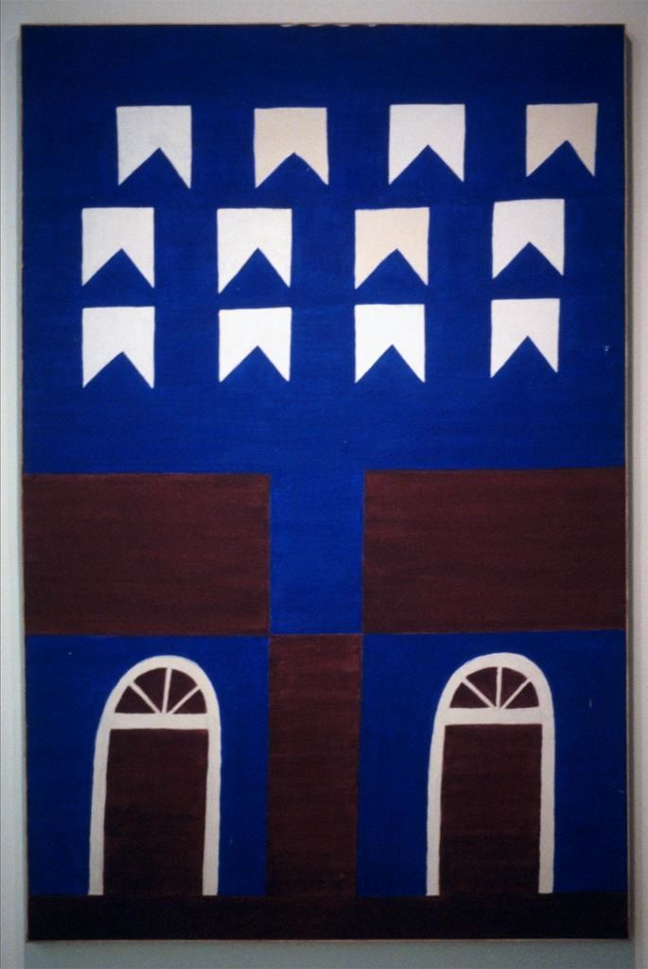

Alfredo Volpi, *Fachada com Portais e Bandeirinhas* *(Façade with Pennants)*, Tempera on Canvas, late 1950s. Details available on: http://library.artstor.org.proxy.lib.duke.edu/library/welcome.html#3|search|1|Alfredo20Volpi|Multiple20Collection20Search|||type3D3126kw3DAlfredo20Volpi26id3Dall26name3DAll20Collections

And:

http://library.artstor.org.proxy.lib.duke.edu/library/iv2.html?parent=true#

**References and further reading:**

Amaral, Aracy (1998) “Construction and reductionism in the light of the tropics” in *XXIV Bienal de São Paulo, Anthropophagy and Histories of Cannibalism* (Exh. Cat.) São Paulo: Fundação Bienal de São Paulo, p. 372-385. Available online at: http://issuu.com/bienal/docs/name208154

Araújo, Olívio Tavares de (2006) *Volpi: A Música da Cor* (exh. cat.) São Paulo: MAM.

Salzstein, Sônia (2000) *Volpi*. Rio de Janeiro: Campos Gerais.

Volpi, Alfredo (1986) *Volpi 90 anos* (exh. cat.) São Paulo: MAM.

**List of Works:**

*Vista of Itanhaém with Ocean* (*Vista de Itanhaém com mar ao fundo*), mid/late 1940s. Private Collection, São Paulo, Brazil.

*Façade with Our Lady of Aparecida* (*Fachada com Nossa Senhora de Aparecida)*, early 1950s, Collection Tito Enrique da Silva Neto, São Paulo, Brazil.

*Concrete Composition* (*Composição Concreta*), mid 1950s. Collection Maria Helena Ortiz, São Paulo, Brazil.

*Composition – Hourglass* (*Composição – Ampulhetas*), late 1950s/early 1960s. Collection Yara and Roberto Baumgart, São Paulo, Brazil.

*Little Flags* (*Bandeirinhas*), mid-1950s. Private Collection, São Paulo, Brazil.

*Façade Elements and Little Flags* (*Elementos de fachada e bandeirinhas*), mid 1960s. Private Collection, São Paulo, Brazil.